Republic of the Philippines

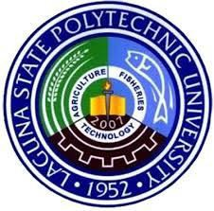

Laguna State Polytechnic University

Province of Laguna

# Office Memorandum, Series of 2022

TO **: *ALL UNIT HEADS***

**NOEMI B. NUÑEZ,** *Guidance and Counseling, Admission and Testing* **JOSEPH ALDRIN C. GANIBO,** *Student Organization and Activities* **MARIFE P. HOSMILLO,** *Student Government and Leadership Training* **MINERVA S. FERNANDEZ,** *Student Publication*

**MA. CZARITA A. AGUJA,** *Spiritual and Multi-Faith Services*

**GELZEN R. JAMOLIN,** *Student with Special Needs*

**DARWIN ALEJANDRINO,** *Social and Community Involvement*

**DULCE B. BITICON,** *Medical and Dental Services*

**ANTONIO G. NIEGAS,** *Food Services*

**ARVIN B. TARUMA,** *Housing and Residential Services* **FRANCIS JOSE DELA CRUZ,** *Sports and Development* **SANDRA P. MESINA,** *International Student Services*

**SANDY JESSIE LYNN LEOBREBA,** *Scholarship and Financial Assistance*

# FROM : JAYSON N. OLAYTA, MRD

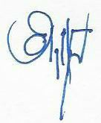

Chairperson, Office of Student Affairs and Services

# SUBJECT : SUBMISSION OF ACCOMPLISHMENT REPORT FOR THE PERIOD OF JANUARY TO MARCH 2022

DATE **:** April 8, 2022

Please be advise to submit the accomplishment report of your respective units for the period of January to March 31, 2022 on/before April 11, 2022. Submission of your accomplishment reports can be sent to our Group Chat. Such accomplishment reports will be consolidated by the office for submission to MIS.

For your information and compliance.

LSPU-OSAS-MO-**018** REV.0 10 August 2016